Application #_________________

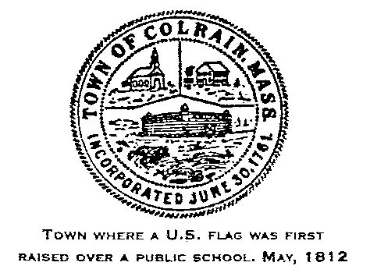
Zoning Board of Appeals
Town of Colrain
55 Main Road
Colrain, MA 01340
Tel 413-624-3454
Fax 413-624-8852

APPLICATION FOR VARIANCE OR SPECIAL PERMIT

- Variance
- Special Permit

Application is hereby made for a Variance or Special Permit in accordance with Section _________________________ of the Colrain Protective Zoning Bylaws
Applicant: ________________________________________________________
Address: _________________________________________________________
Phone #:_______________________________________________
Email Address: _________________________________________
_________________________________________________________________
Owner of Record: __________________________________________________
Address: _________________________________________________________
Premises affected: __________________________________________________
Parcel Identification: ________________________________________________
Deed Book & Page (Registry of Deeds):_________________________________
Zoning District: ____________Type of Structure: _________________________
Proposed setbacks: (front) __________ (side) ___________ (rear) ___________

Description of proposed work in detail:
_________________________________________________________________
__________________________________________________________________________________________________________________________________
_________________________________________________________________
Reason for seeking Variance:
Soil conditions, lot shape, topography: _________________________________
_________________________________________________________________
_________________________________________________________________
Hardship: _________________________________________________________________
_________________________________________________________________

_________________________________________________________________

Town Clerk certifications

Received from applicant this date: ____________________________

____________________________________________
Town Clerk

Transmitted to the Board of Appeals this date: ___________________________
_____________________________________________________
Town Clerk

